1. We’re going to look at the Docker Client (Docker CLI) inside of terminal a little bit more and learn about the very basic commands that we use to interact with docker containers and images.
2. 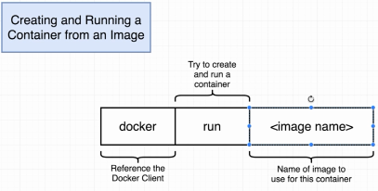  
   We’re going to create and run a container using an image.
3. 
4. Somewhere on our hard disk is the image “hello-world” which has **File System Snapshot with one single program inside it**.
5. 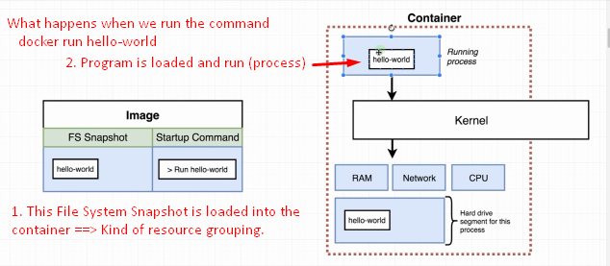
6. A docker run command has a lot of variations. Very subtleties around it. Let’s see in next lecture.